Intelligent Shelves

Ashok Maddineni

Veera Manikanta varma Kanumuri

Sai Krishna Teja Kanubboina

Advisor: DR. ROBERT A GILLILAND

Senior Lecturer

Computer Science, Information, & Engineering Technology

Meshel Hall 318

phone: (330) 941-2808

ragilliland@ysu.edu ragilliland.people.ysu.edu/

**Abstract:**

The Intelligent Shelves project is a cutting-edge initiative that uses modern inventory management strategies to revolutionize the conventional retail environment. Our project was designed to transform the shopping experience in response to the ongoing issues that the retail sector faces, such as inaccurate inventory information, inconsistent product availability, and the need for more efficient inventory management. The main goals of the project are summarized in this abstract, which highlights the importance of constant product availability, user-friendly interfaces, and real-time updates. The project's main goal is to successfully deploy the Intelligent Shelves system, which serves as a foundation for transforming the retail industry and achieving unprecedented levels of productivity and customer satisfaction.

One of the main objectives of the system is to use dynamic digital displays to give customers precise and instantaneous updates on product availability. The creation of an intuitive user interface is of utmost importance as it allows for simple navigation and allows customers to quickly determine the availability of products with minimal assistance. The system also tackles the long-standing problem of erratic product availability, aiming to reduce the number of times that customers come across empty shelves and guarantee that the desired items are continuously stocked. This abstract lays the groundwork for a thorough examination of the project, encouraging readers to delve into the Intelligent Shelves system's technical details, the difficulties encountered in the retail industry, the conclusions drawn from a thorough review of the literature, and the project's overall potential to revolutionize the retail landscape. The following sections of this report offer a thorough understanding of the Intelligent Shelves project and its implications for the future of retail by delving into the project's methodology, technical architecture, testing results, and conclusive findings.

**Introduction:**

The primary aim of this project was to revolutionize the retail environment through the implementation of advanced inventory management techniques. Our key objectives were to ensure consistent product availability, provide real-time updates on product statuses, and cultivate a seamless shopping experience for customers.

This report comprehensively outlines the technical achievements, key project milestones, and the successful deployment of the Intelligent Shelves system.

**Problem Domain:**

In the retail sector, it can be difficult to maintain ideal inventory levels and deliver a flawless shopping experience. Inaccurate inventory data, uneven product availability, and the requirement for effective inventory management systems are all addressed by the Intelligent Shelves project. The project seeks to overcome these obstacles and improve the retail experience in general by utilizing cutting-edge technologies.

**Literature Survey:**

The literature review also explores how consumer expectations and retail technologies are changing. Research on the application of RFID technology to inventory tracking shows promise for improved precision and effectiveness in tracking product movements. Furthermore, studies looking into the relationship between customer satisfaction and real-time updates demonstrate how important timely information is in creating positive shopping experiences.

It is clear from reading the literature that modern consumers not only want but are becoming more and more dependent on a seamless and intuitive user interface. This is in line with the wider retail trend of improving the customer journey as a whole. The Intelligent Shelves project is based on a literature review that looks at how effective inventory management affects the retail sector. Through the integration of ideas from these various sources, our project not only adds to the current conversation in retail technology, but it also puts itself at the forefront of innovation when it comes to solving modern problems.

**Requirements:**

* Real-Time Inventory Updates: Customers require a system that provides accurate and real-time updates on product availability. They expect to see product availability on digital screens in real time, ensuring that the items they intend to purchase are in stock.
* Ease of Use: Customers desire a user-friendly interface on digital screens that allows them to quickly and easily check product availability. The interface should be intuitive and straightforward, requiring minimal guidance.
* Consistent Availability: Customers expect products to be consistently available. They want to reduce instances of encountering empty shelves, ensuring that the store has the items they need.
* Efficient Shopping: Customers value an efficient and pleasant shopping experience. They want to find products quickly and easily, without the frustration of searching for out-of-stock items.

**System Requirements:**

* Real-Time Data Processing:
  + The system must be capable of processing data in real time, ensuring that changes in inventory due to item removal or insertion are immediately reflected on digital screens.
  + Simulated Software: The system must include simulated software to mimic the external environment accurately. This simulated environment should provide a realistic representation of inventory movements and updates for testing and optimization.
* Backend Functionality:
  + The backend of the system should be developed to handle data processing, inventory tracking, and communication with the simulated software.
* Frontend User Interface:
  + The frontend for digital screens should provide an intuitive user interface for displaying real-time inventory status.
  + It must offer seamless integration with the backend for data retrieval and display.

**System Architecture:**

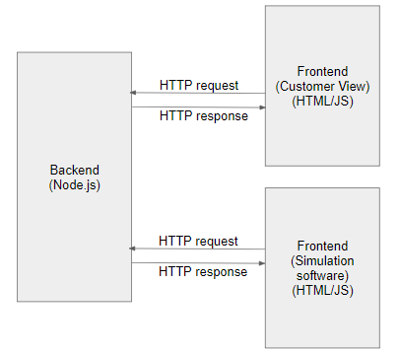

**Frontend Customer View:**

It will display the complete store view to the customer. Along with the shelves, it will also display the quantity (/stock) of the items in that rack.

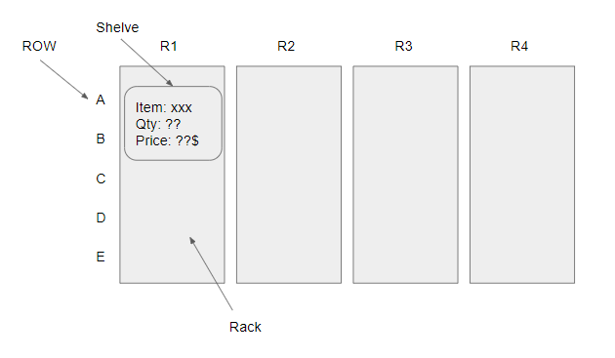

**Frontend Simulation Software:**

This simulation software will simulate the physical events like removing or adding items from or to the rack (which will actually be detected by RFID technology in real world)

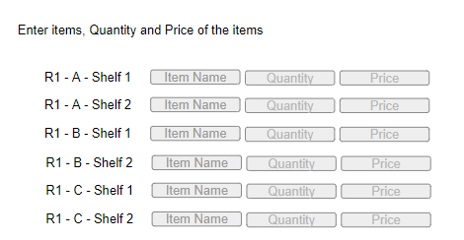

**Backend:**

Backend will handle events from both simulation software and customer view.

Whenever certain items are removed or added in simulation software, the same will be updated in the database through the backend.

Below are some of the major APIs that we created in the backend.

GET/store_structure

Used by both the front-ends to know the store structure (like how many racks were present, rows and shelf details).

GET/shelf_data

Used to get the details of shelf (like item in the shelf, quantity and price)

PUT/shelf_data

Used to update the items or quantity or price of the item on the shelf.

**Technical Results:**

We have achieved the all phases mentioned in the initial project plan, including the successful implementation of software (frontend and backend) components, testing and deployment.

Testing has shown that the core functionality, including real-time inventory updates, is operational.

Some technical issues, such as data synchronization and minor performance bottlenecks, have been identified and are addressed.

**Backend Testing: (GET store_structure API)**

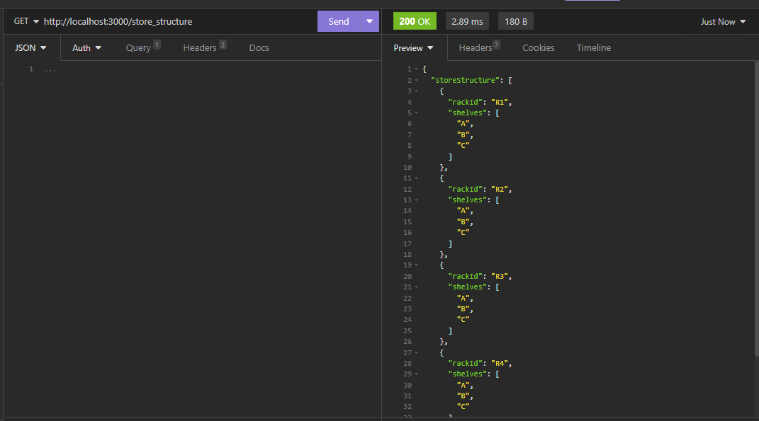

**Backend Testing: (GET shelf_data API)**

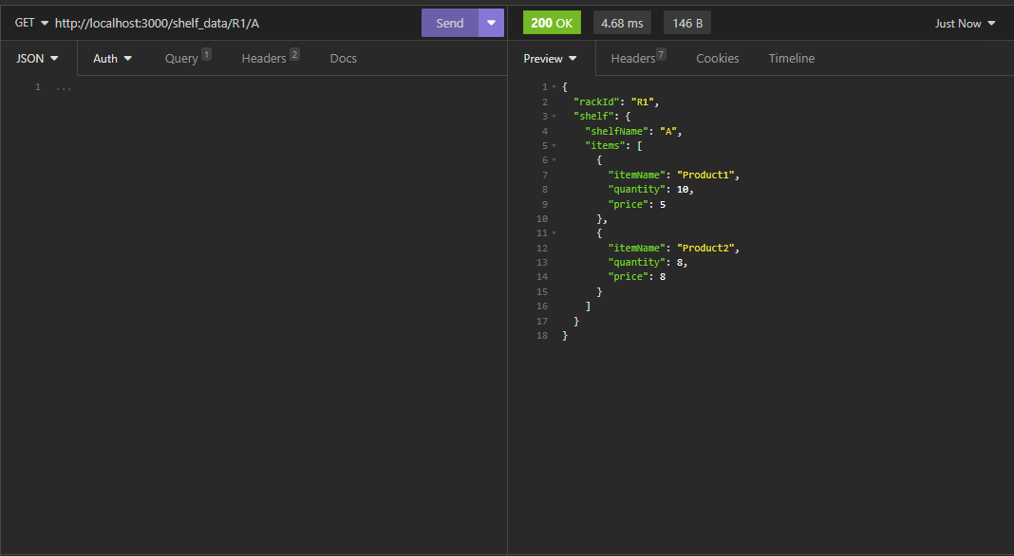

**Backend Testing: (PUT shelf_item API)**

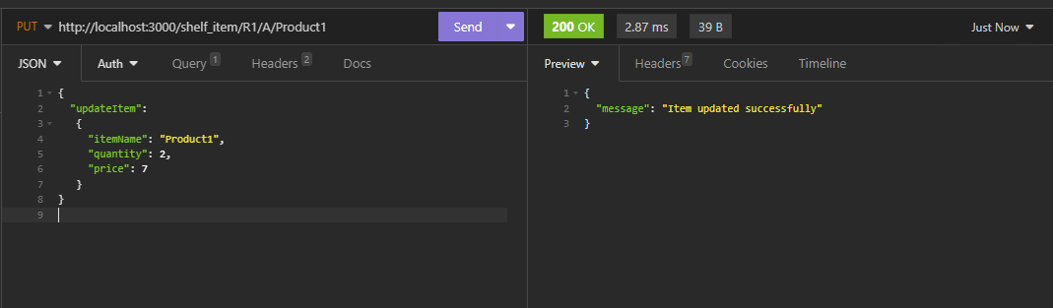

**Front end testing (Store view)**

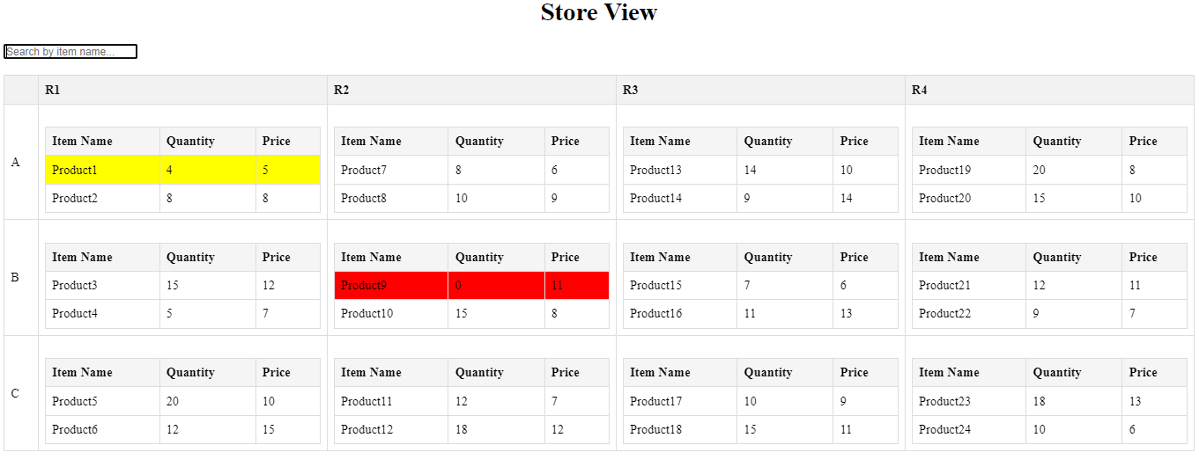

**Front end Testing:** Displays warning sign in realtime when stock is low and becomes zero

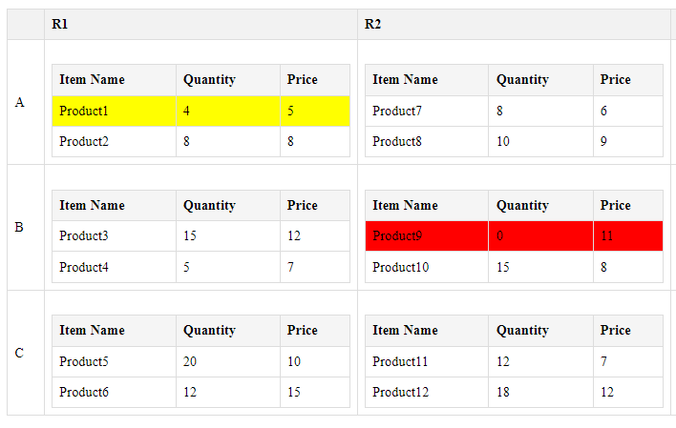

**Front end Testing:** Search option to quickly search for the desired item

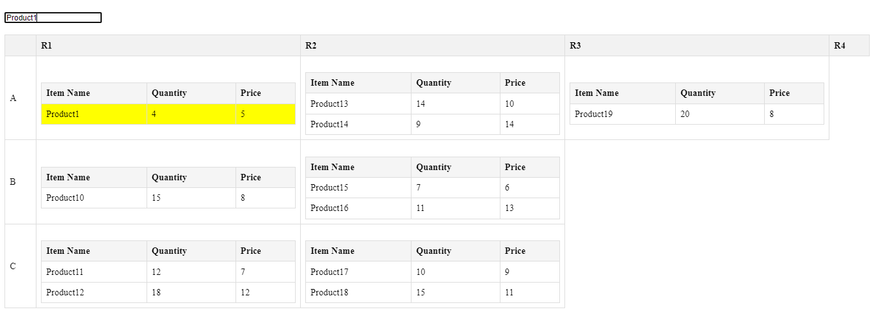

**Front end Testing: (Simulator)**

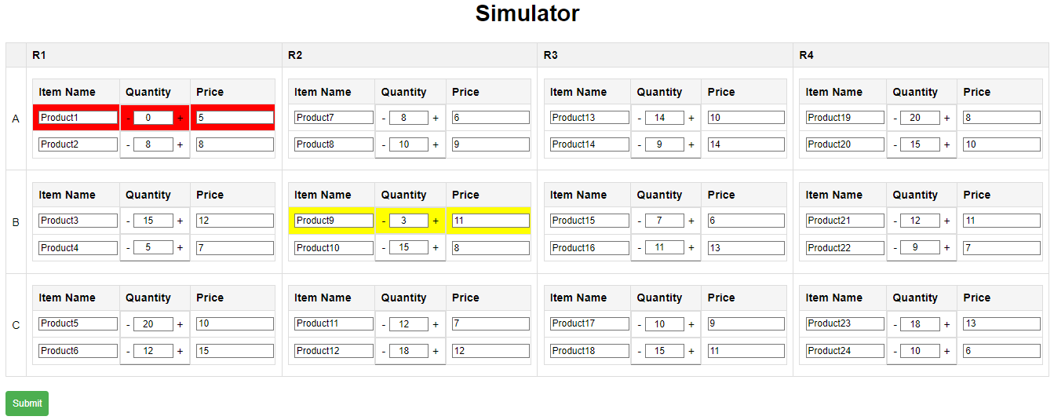

**Summary:**

With its sophisticated simulation software that emulates user shopping behavior and lets items be removed from virtual shelves with dynamic quantity value adjustments in line, the project has successfully met all of its planned requirements.

An improved and immersive user experience is ensured by the store view's frequent refreshes and real-time updates.

A centralized, responsive system that allows for precise tracking and fast reaction to stock changes is made possible by the smooth synchronization between simulation actions and store view updates.

**References:**

1. Lee, D. (2016). Smart Shelves for Smart Stores: A Review of RFID Technology in Retail. Journal of Theoretical and Applied Electronic Commerce Research, 11(2), 19-34.
2. Chen, H., & Huang, Y. (2018). Smart Shelf System Design Based on RFID and Wireless Sensor Network Technologies. International Journal of Distributed Sensor Networks, 14(12), 1550147718814485.
3. Bhuiyan, M. Z. A., Islam, S. M. R., & Kwak, K. S. (2016). RFID and IoT for Smart Library: A Survey. Journal of Electrical Engineering and Automation, 1(1), 29-40.
4. Sundarakannan, B., Manogaran, G., Lopez, D., & Thota, C. (2017). A new architecture of Internet of Things and big data ecosystem for secured smart healthcare monitoring and alerting system. Future Generation Computer Systems, 82, 375-387.